Assignment 2 Report

Group 3: Mandira Samaraseakara

Kyle Thaw

Difference in performance between Mouse and Touchpad

We created a game in unity to test the difference in performance between Mouse and Touchpad. We got 3 people to participate in this experiment. Each person played the game once using the mouse another time using a Touchpad and we recorded the timings of the Selections. The game consisted of a circular target which would move around in a sequence and the combination of width and amplitude should be changed every 9 clicks.

We calculated the Fitts ID for each unique combination of amplitude and width.

For each unique Fitts ID we calculated the mean time of selection for the mouse and the Touchpad and plotted the graph as shown below:

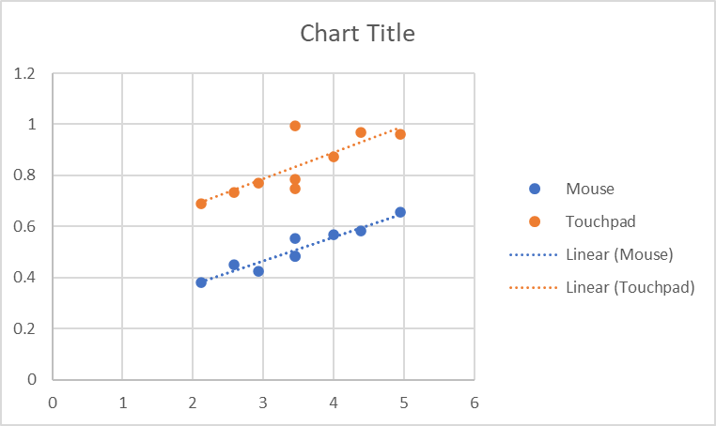

This graph shows that the selection time using a mouse is consistently lower than the selection time when using a Touchpad. It also shows that the higher the Fitts ID the higher the higher its resulting selection time. Therefore the fastest selection time was achieved using the mouse as an input technique and Fitts ID of “2.115477217” (Amplitude = 5, Width = 1.5).

Challenges we faced, and how we overcame them

* Made two initial objects; the target and the other circles. But we changed it to one object, just the circles, and coded only the target to change to red so that when we click on the red target, the colour changes back to white and the next circle in the sequence changes to red.
* Had to search up the formula to arrange the objects in a circle: X: 4\*cos(L(0,(16/9)\*pi)). Y : 4\*sin(L(0,(16/9)\*pi)). Had problems arranging it at first since I used “2” instead of “16/9” which was needed for 9 objects.
* We tried using multiple scenes to do the sequence however it did not work.
  + Solution: made a serialised array and put all the circles in one scene.
* Problem putting the game objects in the required sequence because when we were changing the distance, the formula tampered with the array where the sequence of the targets were stored. Which led to the targets moving in a circular pattern instead of a sequence. To fix that, we stored the sequence in a different array.
* We tried to change the width and amplitude using different scenes but this didn't work as we expected.
  + We took a different approach where we created an enum, giving it three values for each of width and amplitude. For width, we changed it by accessing the objects’ scale. For amplitude, we changed it by using the formula we used to position the objects in a circle. They were done by creating a new vector3 for the position and for the scale of the object. And then we set the position and the scale of the object to that vector3.
* We performed 90 clicks per person where the person had to do 9 selections for the first unique combination of width and amplitude, and 10 clicks for the rest, this was because after the 9th selection we had to change the combination of width and amplitude manually which took more time than simple selection. Hence we set it up in such a way that it ignores the 10th attempt after the first combination and this results in accurate data.
* When we tried to save timing data in a csv file the program threw an error stating that access was denied to this memory location. Solution: we ran unity as an administrator and this error was solved.
* When we tried to log whether the selection was correct or not we put a square with its own collider to cover the entire background and activated its “is trigger”, so if the square was clicked it would record 1 in the error log to indicate that an error was made else it would remain 0. But this caused an issue where the square collider would be triggered even when the correct circle was clicked. Solution: we switched to 3D mode and moved the square background to be placed behind the circles therefore there was no more overlap of the 2 colliders.
* One of our group members had a different version of unity from 2022.3.34f1 therefore we had to do some adjustments when moving the project across computers with different unity versions. We downloaded the correct version on the computer we built the game in and updated the version of the project to 2022.3.34f1.

How we collaborated and divided the tasks among group members

We met up regularly and coded the game on the same computer. However for testing with a touchpad we moved the project to another computer

Mandira Samarasekara’s Tasks

* Logged the data and performed Analysis and fits law calculations
* Wrote the scripts “ControlCentre” and “InputHandler”
* Helped debug “Data Logger”
* Implemented the 3 widths using enum
* Implemented the selection sequence
* Fixed the “correct selection (1 or 0)” issue
* Wrote the report

Kyle Thaw’s Tasks

* Wrote the “Data Logger” script
* Helped debug “ControlCentre” and “InputHandler”
* Designed majority of the scene, target and remaining circle objects
* Implemented the 3 distances using enum
* Made the 3 mins gameplay video
* Made adjustments to the report